**Assignment 01**

**Project Lists/Descriptions**

**Submission deadline: Oct. 29 23:59 (Seoul, Korea)**

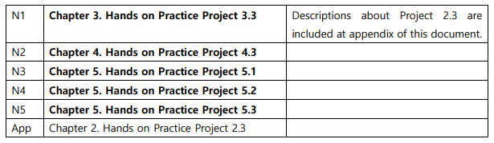

Reference Materials on eClass “open bulletin board”

**N1: Chapter 3. Hands on Practice Project 3.3**

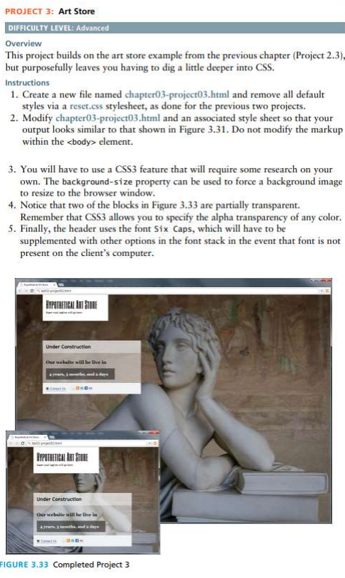

**N2: Chapter 4. Hands on Practice Project 4.3**

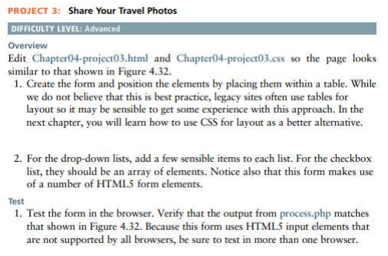

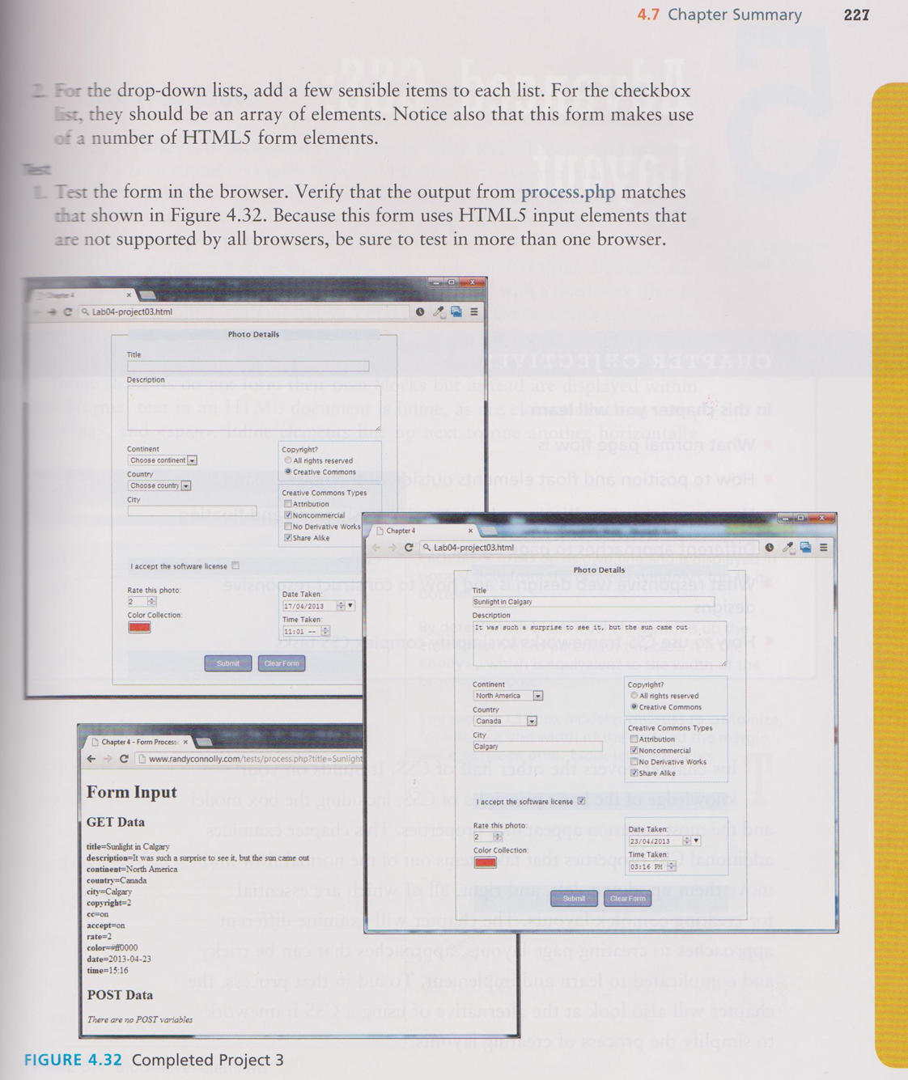

**N3: Chapter 5. Hands on Practice Project 5.1**

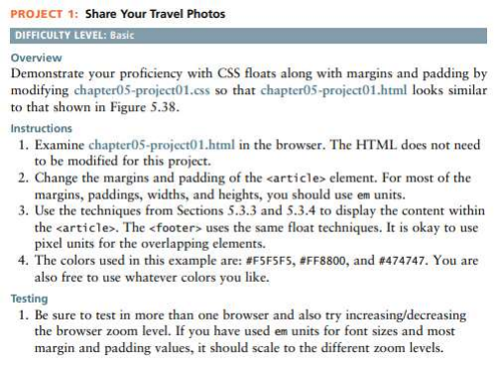

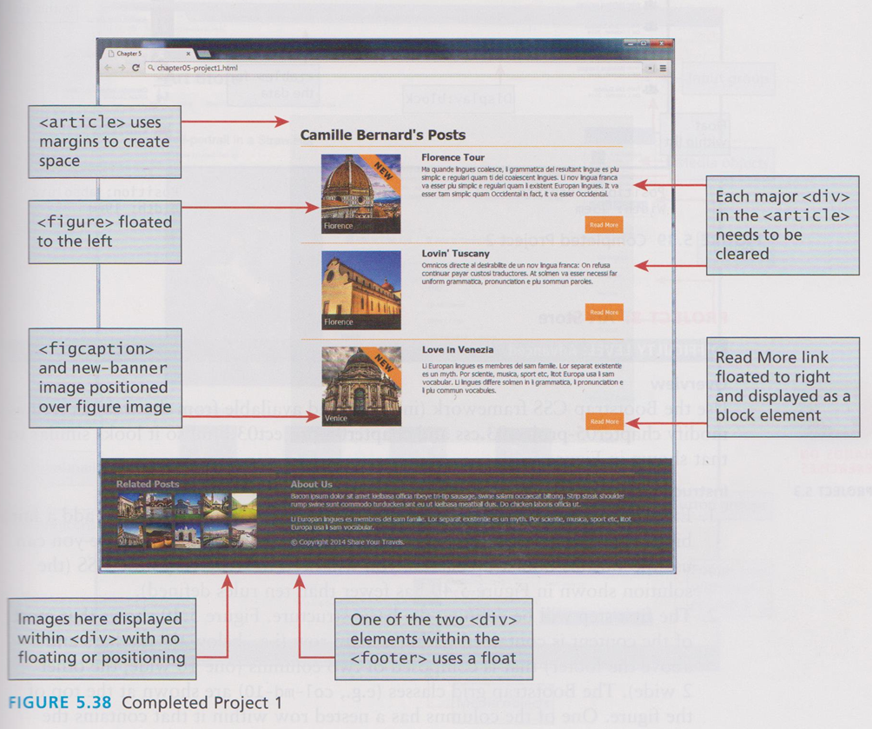

**N4: Chapter 5. Hands on Practice Project 5.2**

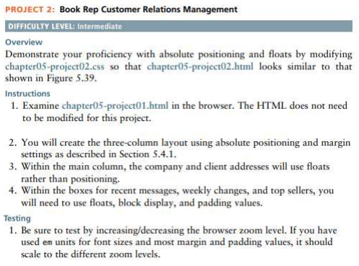

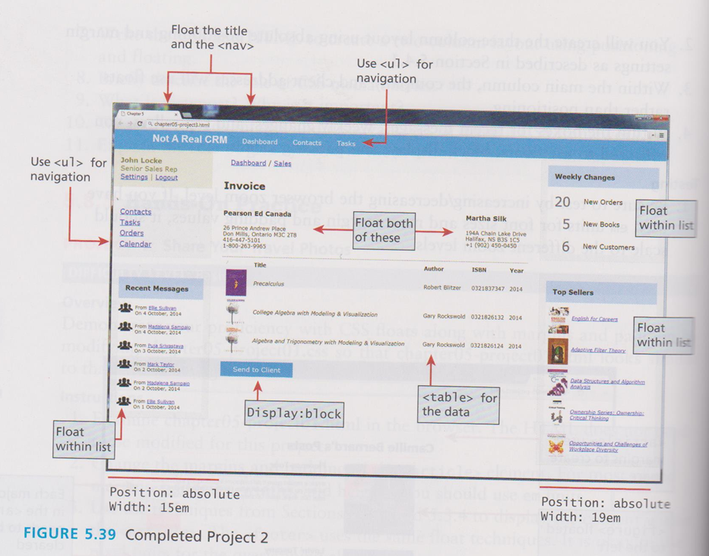

**N5: Chapter 5. Hands on Practice Project 5.3**

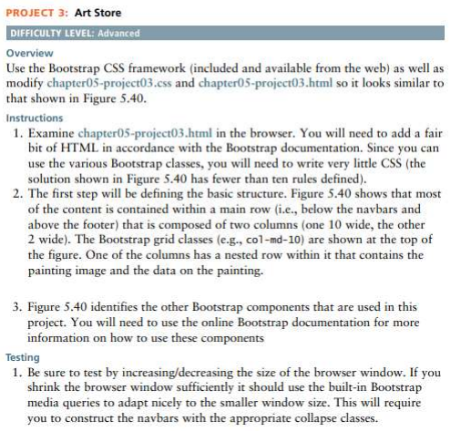

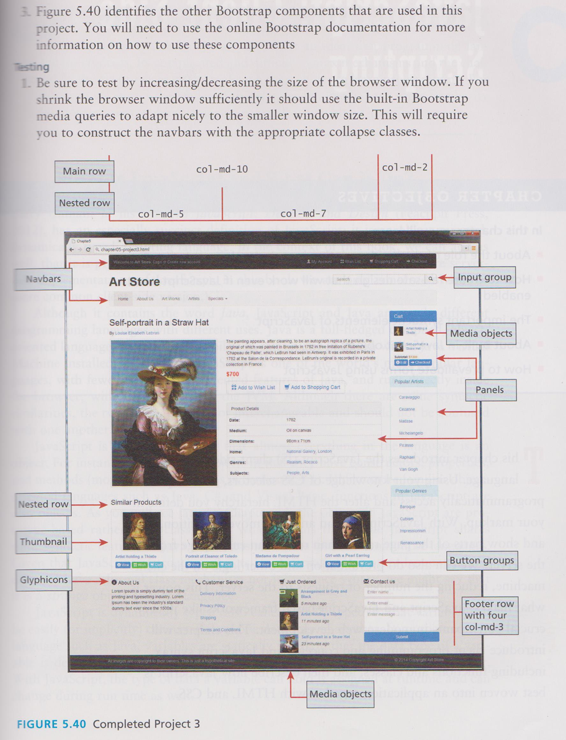

**Appendix. Chapter 2. Hands on Practice Project 2.3**

